Quick Setup Instructions
Step 1: Install Python
- Download Python 3.8+ from https://python.org
- During installation, check "Add Python to PATH"
Step 2: Open Command Prompt
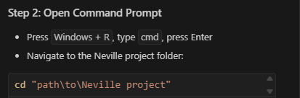
Step 3: Install Dependencies
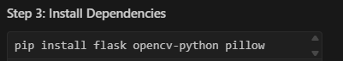
pip install flask opencv-python pillow
Step 4: Run the Project
python app.py
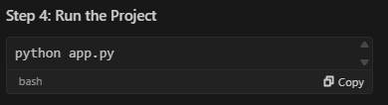
Step 5: Access the Website
- Open browser and go to: http://localhost:5000
That's it! 🎉
How to Use:
- Register Students: Go to Register page, add student details + photo
- Track Attendance: Go to Attendance page, click "Start Camera"
- View Reports: Go to Reports page to see attendance records

Troubleshooting:
Files Included:
- app.py - Main application
- database_sqlite.py - Database (auto-creates)
- face_detection_basic.py - Face detection
- templates/ - Web pages
- static/uploads/
- Student photos storage
No MySQL setup needed - uses SQLite database that creates automatically!

